Table of Contents

Introduction (Section 1) 1-3

Project Overview and Justification

Aims and Objectives

Website Design (Section 2) 2-6

Flowcharts

Interface design

Website Implementation (Section 2) 6-8

Main page

Location pages

JavaScript algorithms

Results and Discussion (Section 3) 14-15

Testing

Conclusion and Further Work (Section 3) 15-16

Aims and Objectives

Improvements

**Introduction**

**Project Overview**

The real estate industry is one of the largest industries in the UK, valued at £400 Billion the industry is going through a period of accelerated growth, (REFERENCE). This growth has led to a requirement for the efficient marketing of properties, web technologies can help to achieve this. Web technologies are used throughout the world, today the web industry is valued at $400 Billion with over 5 Billion users worldwide, a number predicted to increase, (REFERENCE).

Guided by user feedback and testing, a website will be developed using CSS, HTML and JavaScript. This website will market differing properties offering customers useful information such as contact information, cost, locations, and benefits.

**Aims and Objectives**

According to a 2022 survey, 87% of shoppers said they were more likely to buy from a website if it was aesthetically pleasing and provided relevant detailed information, therefore, steps must be taken to ensure the site is well-detailed and aesthetically pleasing to a range of cultures, (REFERENCE). Accessibility must be maintained throughout the site, annually 1billion is diagnosed with a disability worldwide, (REFERENCE), a statistic that continues to grow.

**Aims**

* The website is aesthetically pleasing.
* Relevant helpful information is displayed.
* The site is accessible.
* It is easy to find relevant information.
* The website is responsive.
* Users can enquire using the site.

**Website Design**

The website will be designed using CSS, HTML and JavaScript, supported by a range of browsers these languages provide the structure, styling and interaction of the site. The website will be designed within this section, adhering to the aims and objectives outlined above.

**Flowcharts**

This flowchart follows the steps users would take to view differing parts of the site, this design method provides clarity, allowing the interface to be adapted ensuring accessibility and ease of use.

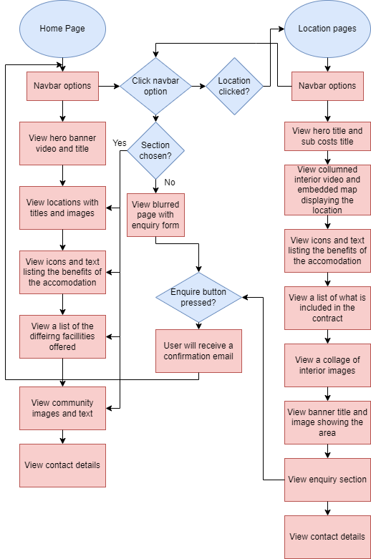**Figure .1** User flowchart detailing the process users follow on the site.

**Figure 2.** Flowcharts detailing the flow of execution within the JavaScript program.

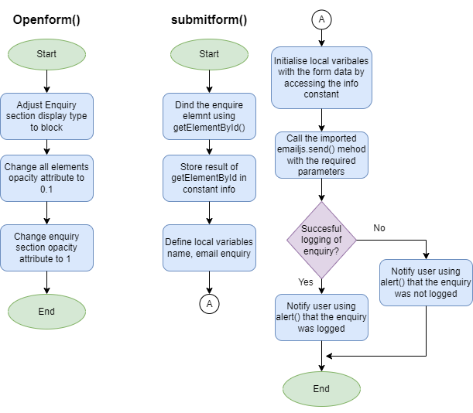

**Interface Design**

This interface design is based on similar sites, as familiarity increases the intuitiveness of an Interface (REFERENCE USING IN PYTHON). The font family used throughout the site is “Poppins”, this font increases the interface's readability due to its prevalence across the web and its spaced soft characteristics (REFERENCE).

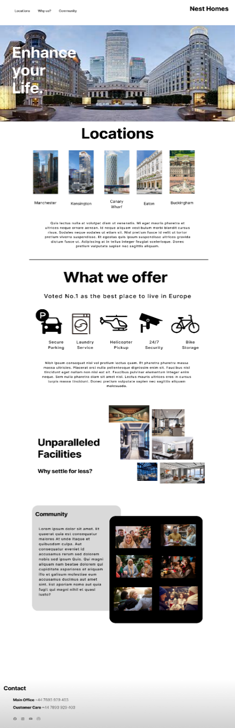**Figure 4.** Initial design of website landing interface

This interface design contains the information typically required for real estate sites (REFERENCE), it contains:

* Location
* Contact information.
* Facilities
* Benefits

This page will act as a landing page, it advertises the accommodation, intriguing the user and prompting them to explore the company's services further by clicking on the differing links.

The page will contain many links that can be used to navigate to differing pages and sections, increasing usability, ensuring users stay on the site for longer. This page will also contain interactive elements to highlight key aspects and information to the user such as; awards, contact information and images. This intractability increases ease of use and holds user attention increasing the probability of a purchase (REFERENCE).

A single style sheet was used for the differing HTML pages of the location interfaces to increase the sites' efficiency. These pages differed slightly, displaying relevant information about each location, this similarity improved readability and use.

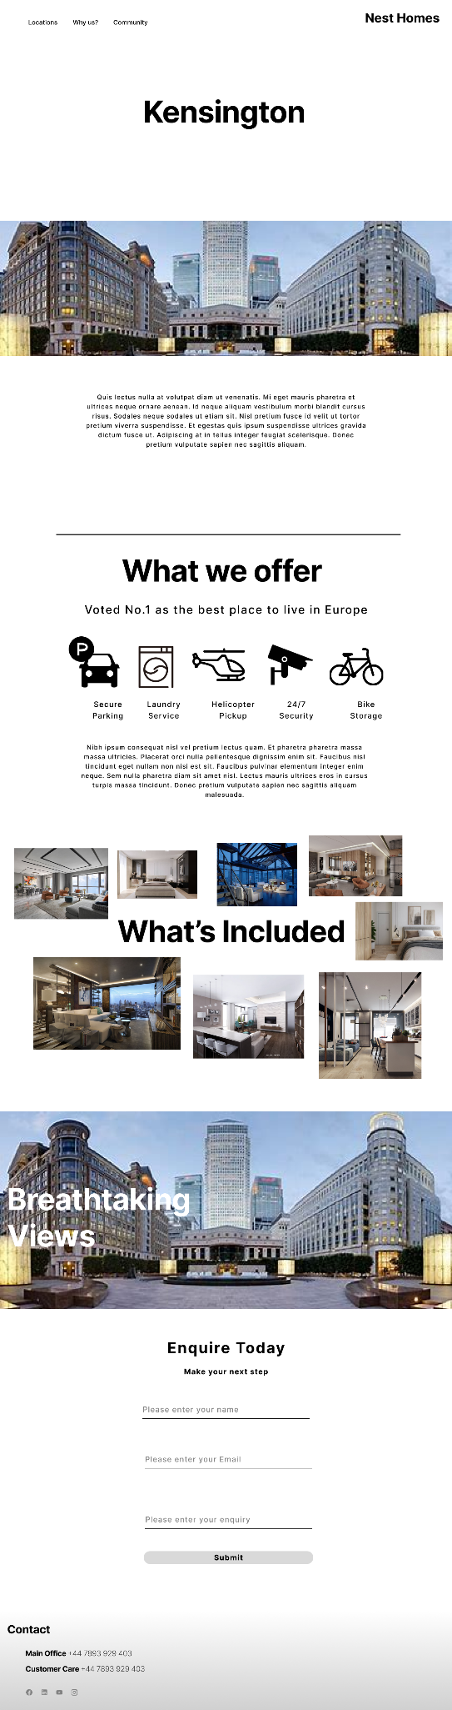**Figure 5.** Initial design of website location pages

**Website Implementation**

The website has been implemented using HTML, CSS and JavaScript, these languages are incredibly portable and efficient allowing the site to be styled to design specifications across a range of devices (REFERENCE).

**HTML (Hypertext Markup Language)** has been used to provide the structural foundation of web pages; it dictates how content is organised on the web page using tags (HTML REFERENCE).

**CSS (Cascading Style Sheets)** is utilised for the styling and layout of elements specified in the HTML file enabling finite adjustments of elements, changing their positioning, colour, and other visual aspects (CSS REFERENCE).

**JavaScript** adds functionality to the page, it adds interactivity and dynamicity. Within this website, it is used to add interactive features such as the enquiry button and contact forms, that send an email receipt of the request (JAVASCRIPT REFERENCE)

On average 60% of internet users access web pages on their mobile devices, therefore, considerations for differing devices have been made, the website has been made responsive to accommodate for all screen types (REFERENCE).

**Main Page**

This page is the main page designed to sell the accommodation and display the services provided, it also offers the user easy navigation to other pages via the navbar.

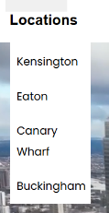**Figure 6.** Navbar of the main page

The navbar uses a simplified look with spacing in between the differing anchor tags using the in-line display type. The “location” anchor elements will display a dropdown menu directing users to the differing locations, using the hover CSS selector.

When screen width is reduced these elements will switch to an inline-block display type to maintain readability, with the dropdown menu being removed.

The dropdown menu improves accessibility and ease of use, by making it easier to navigate to specific areas quickly, as location page links were not previously identified.

Different from the initial design, the company's logo has been displayed in the navbar using an image and anchor tag, when clicked the user will be navigated back to the main page. When clicked, the navbar’s anchor tags will scroll smoothly to the particular part of the page using element IDs as directives.

**HTML**

<li><a class="Community" href="#CommunityColumn1" id="sign-up"><h3>Community</h3></a></li>

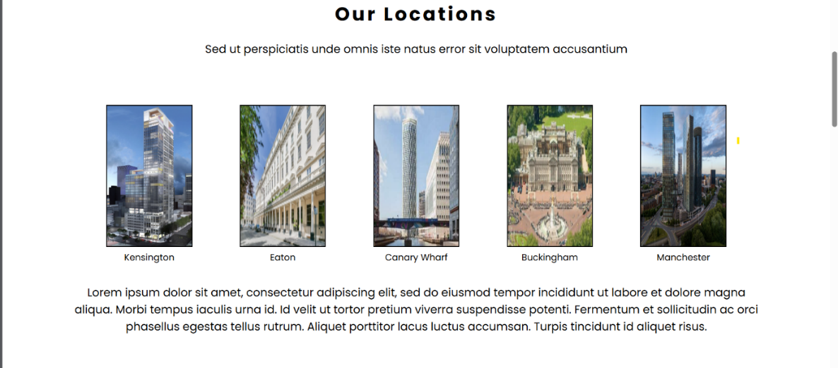**Figure 7.** The location section of the main page

This part of the page is responsible for displaying the differing locations available for purchase, these are displayed as image tags within anchor tags therefore can be interacted with. Once clicked the images will direct the user to the respective pages using anchor tags changing the directory.

**HTML**

<figure>

        <a href= "Kensington.html"> <img id="Kensington" src="Kensington.jpg" alt="Web-Logo" width="150px" height="250x"></a> *<!--https://www.skyscrapercenter.com/building/kensington-tower/36304-->*

        <figcaption>Kensington</figcaption>

      </figure>

Initially the images were displayed separately to the captions and styled to match each other, however, this method proved to be ineffective during iterative testing of the pages responsiveness. Due to this, Fig caption elements were used, tying the caption and image together therefore the elements would shrink in size together and maintain their readability throughout differing screen types.

**Figure 8.** The benefits section of the main page

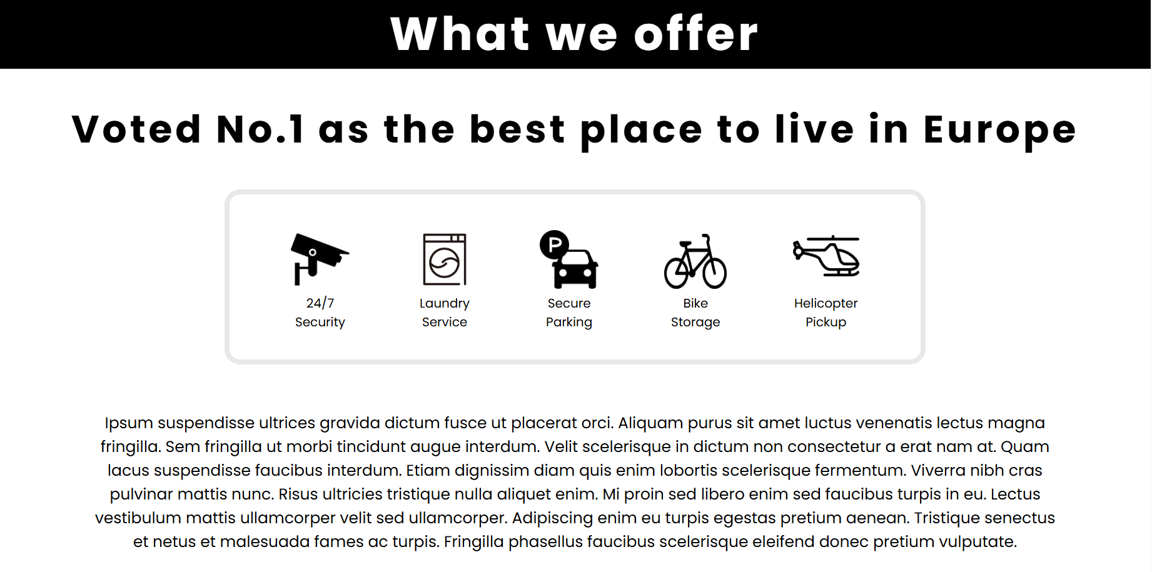

The part of the page details the benefits of the accommodation in a simplistic format. This section works similarly to the locations section displaying icons in an inline display, the icons are captioned with their description improving readability and accessibility.

Captioning icons also increases their understanding across cultures as icons can have differing meanings in differing cultures (REFERENCE).

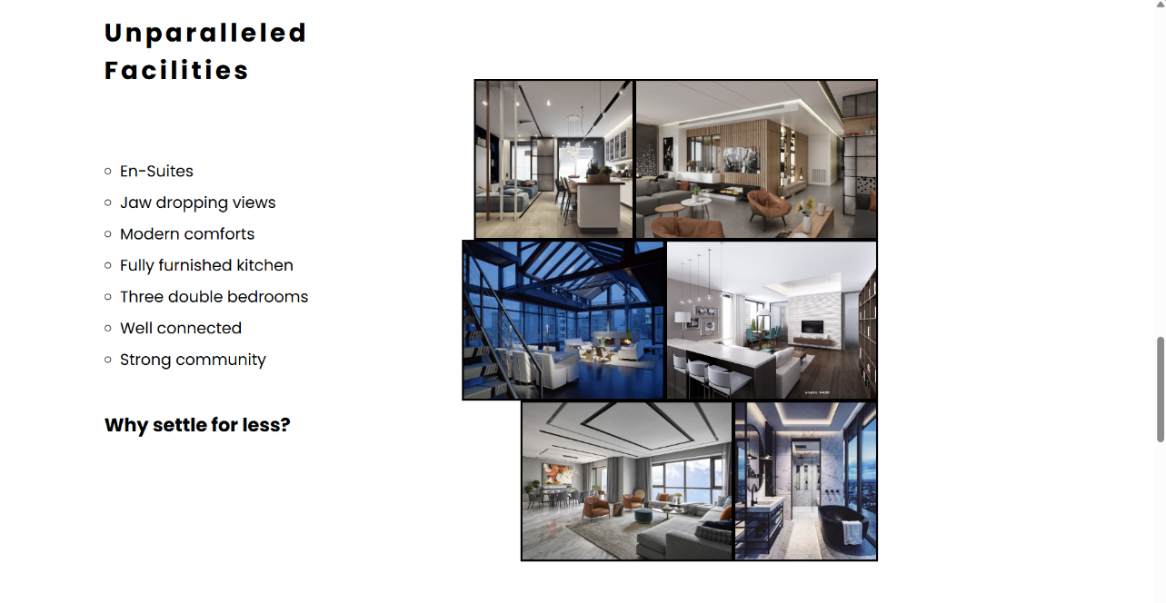**Figure 9.** The benefits section of the main page

This section of the page details the accommodation facilities, the page is split into two columns displaying an unordered list on the left and a collage on the right. Splitting the page saves space increasing ease of use and lowering webpage resource requirements.

This style of design lacked responsiveness with elements being pushed to the side and out of view, reducing the site's readability. To combat this the image collage has been styled to have no overflow removing images that are too big for the screen. The right column will also float to the right maintaining its position regardless of screen size.

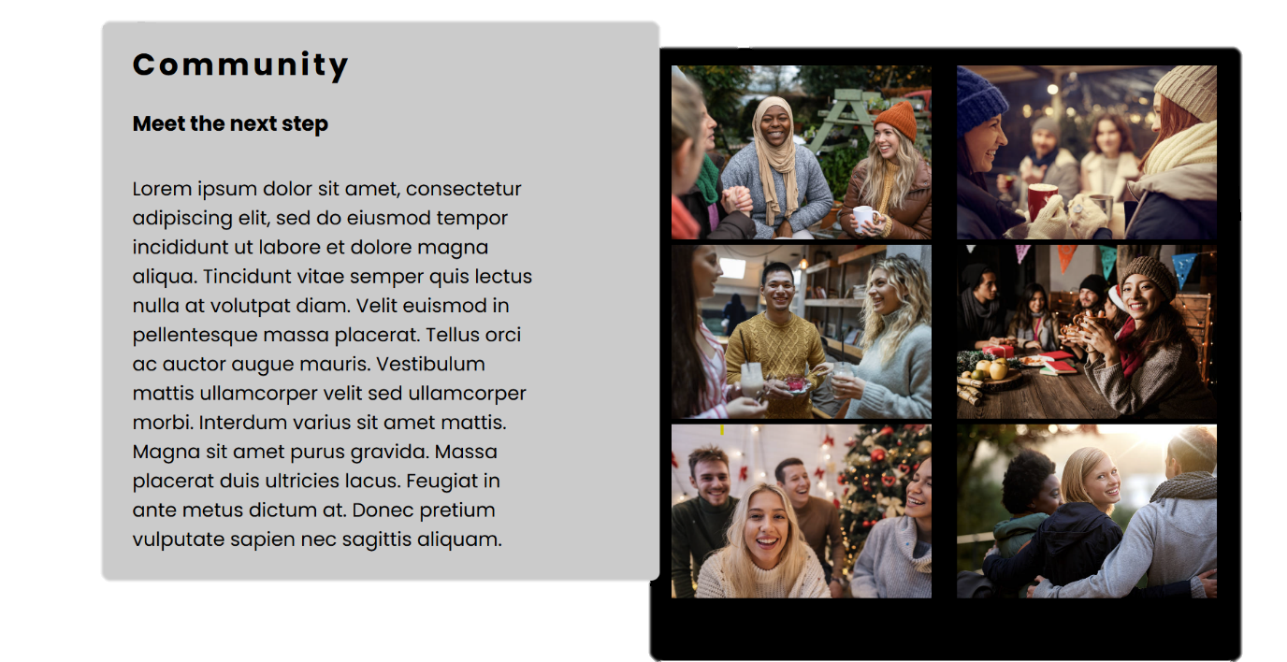**Figure 10.** The main page’s community section

This section of the page displays the community aspect of the accommodation, community is one of the biggest factors considered when buying accommodation (REFERENCE). Like the benefit section, this part of the page splits the page into two columns, these columns are padded and coloured with contrasting colours improving readability.

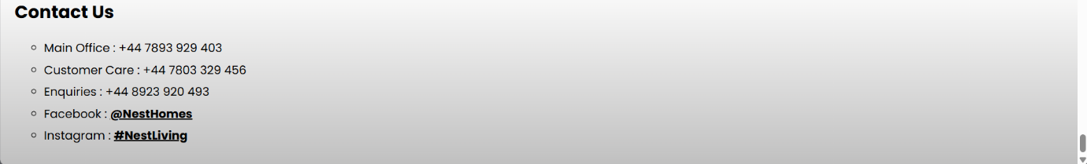**Figure 11.** Contact section of the website

This part of the page is duplicated across all pages on the website, it displays the company contact details using an unordered list, and key parts of the details have differing font weights improving the site accessibility and ease of use.

The background has a linear gradient to contrast the text making it easier to identify the contact information, this gradient conforms to the page's colour palette.

**Location Pages**

These pages are very similar to each other, which allows the use of one cascading style sheet improving the site efficiency and development as readability is increased.

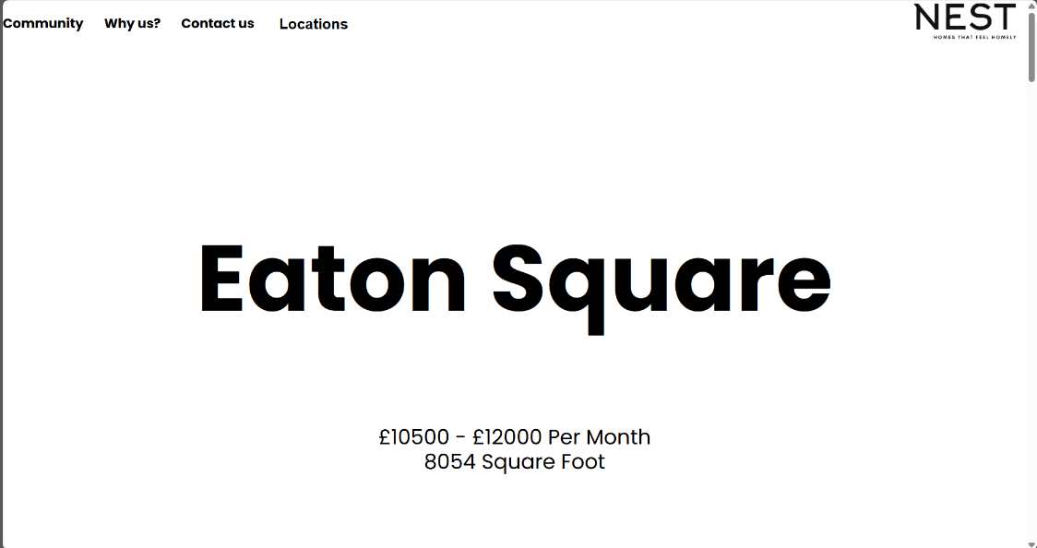**Figure 12.** Location pages hero title and subtitle

The user will first be greeted with a hero banner and subtitle displaying key information such as the cost, size and location. The banner has a 100% width, and the font size is based on viewport width. Determined by screen width the font size will shrink to accommodate differing screen sizes.

**Figure 13.** Location pages video and embedded map

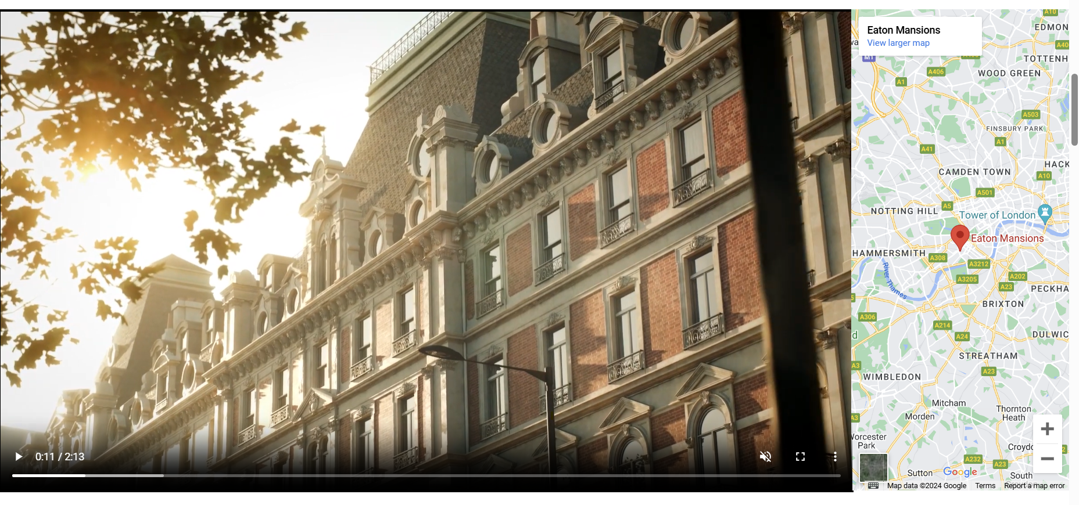Similar to the above section, the user will be greeted with a full width display. This display contains two elements a video and an embedded google map showing the accommodations interior and location.

**HTML**

<div class = "Overview">

    <video  class = "Interiorvid" width = "50%" height = "10%" muted controls autoplay loop> *<!--https://youtu.be/GJ9BkblyfWg-->*

        <source src="KensingtonInterior.mp4" type="video/mp4">

    </video>

    <iframe class = "Map" src="https://www.google.com/maps/embed?pb=!1m18!1m12!1m3!1d4967.94794629633!2d-0.20941607772890755!3d51.495345099999994!2m3!1f0!2f0!3f0!3m2!1i1024!2i768!4f13.1!3m3!1m2!1s0x48760fc8e1e486b9%3A0x797616da9f45aaae!2sLuxurious%20Apartment%20in%20Kensington%20%26%20Chelsea!5e0!3m2!1sen!2suk!4v1714435963219!5m2!1sen!2suk" width="100%" height="100%" style="border:0;" allowfullscreen="" loading="lazy" referrerpolicy="no-referrer-when-downgrade"></iframe>

</div>

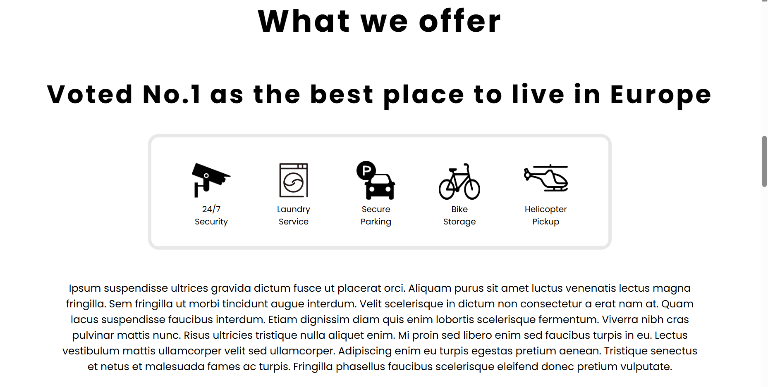**Figure 14.** Benefits section of the location pages

The benefits section is copied from the main page, it is beneficial and necessary to all accommodations, this also saves development time and improves the page's load times as styling can be reused.

Using the hover CSS selector when hovered over the subtitle will be enlarged using the “scale ()” method highlighting this selling point.

**CSS**

.ScrollText:hover{

  transform: scale(1.1);

}

**Figure 15.** Interior image collage within the benefits section of the location pages

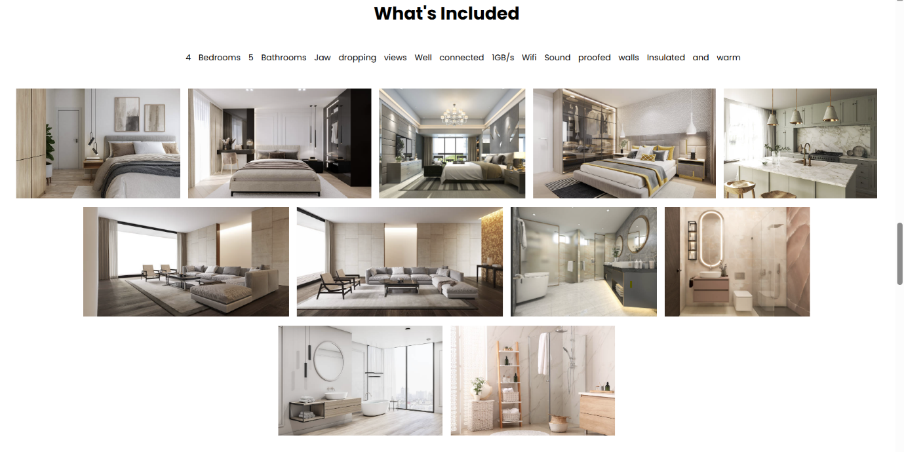

Displayed in the benefits section, is a collage of images with equal padding is displayed, this collage comprises many images of the accommodation's interior. As well as a collage further benefits are detailed in an unordered list styled with an “inline” display.

To ensure the site's dynamicity and accessibility the image collage has a display type of “flex box”. This display type ensures that elements stay within the screen width, in this case, the elements will become a display type of “inline block” as the screen width shrinks.

**CSS**

.Facilities img{

  display:flex-box;

  padding:5px;

}

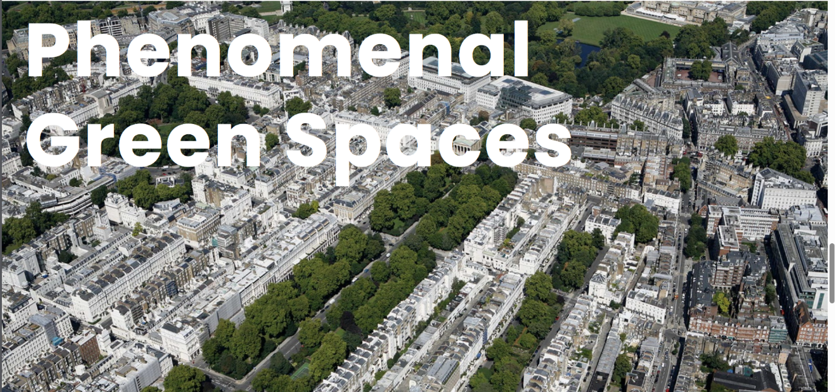**Figure 16.** Hero banner displaying the immediate area of the accommodation

Using the same CSS and HTML as the main page’s hero banner, this section of the page displays the area around the accommodation.

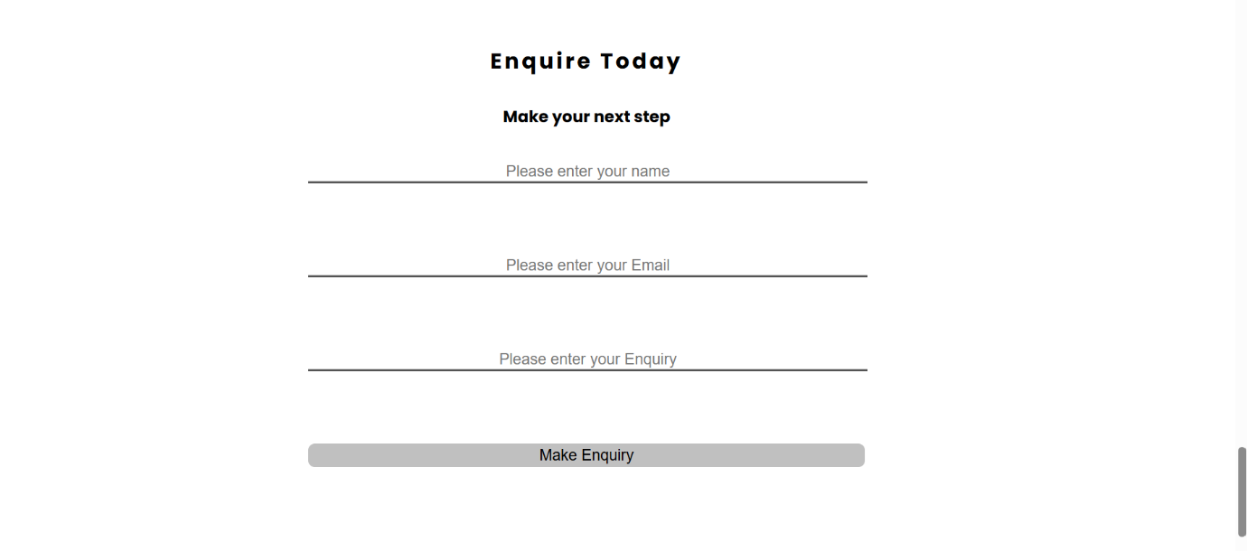**Figure 17.** Enquiry section of the location pages

Using form tags, this enquiry form will take in user data and process this using JavaScript algorithms, the user will receive an email confirmation of their enquiry. Each input has been spaced, titled and has a type to improve readability and ease of use allowing for software ot autofill the form.

**HTML**

<form action="">

        <input type = "text" id="inpname" name = "name" placeholder = "Please enter your name">

        <input type = "text" id = "inpemail" name="email" placeholder="Please enter your Email">

        <input type = "text" id = "inpenquiry" name="enquiry" placeholder="Please enter your Enquiry">

        <input id = "submitbutt" type="submit" value="Make Enquiry">

**JavaScript algorithms**

JavaScript plays a key role within the webpage, it is used to handle enquiries responding to enquiries with an automatic email.

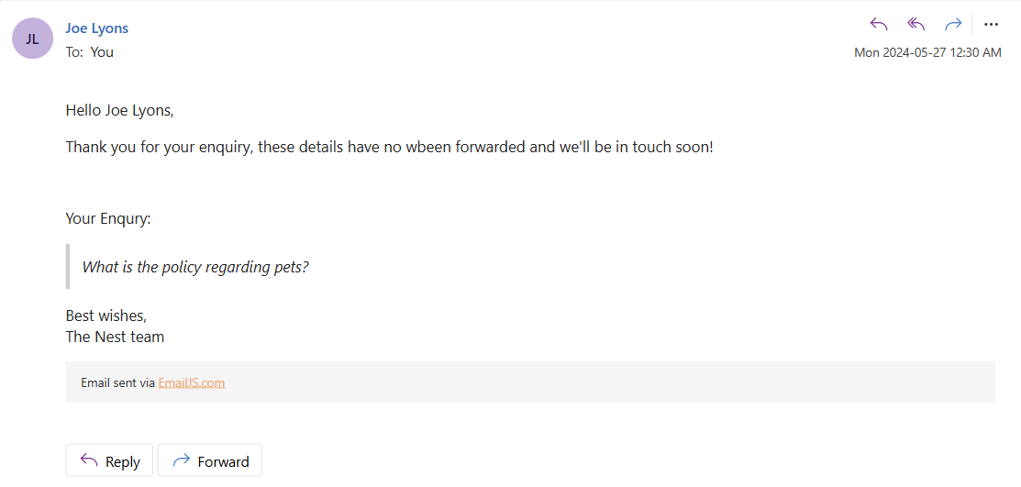**Figure 18.** Email users receive after the enquiry is made.

When a user presses the contact button within the main page Navbar an input form will be displayed, this is achieved by calling the “openform()” JavaScript function that edits the page's CSS changing the form elements display type, z-index and changing the opacity of other page elements.

**JavaScript openform() function**

**function** openform(){

    document.getElementById("EnquireSection").style.display = "block";

    document.getElementById("html").style.opacity = "0.1";

    document.getElementById("EnquireSection").style.opacity = "1";

}

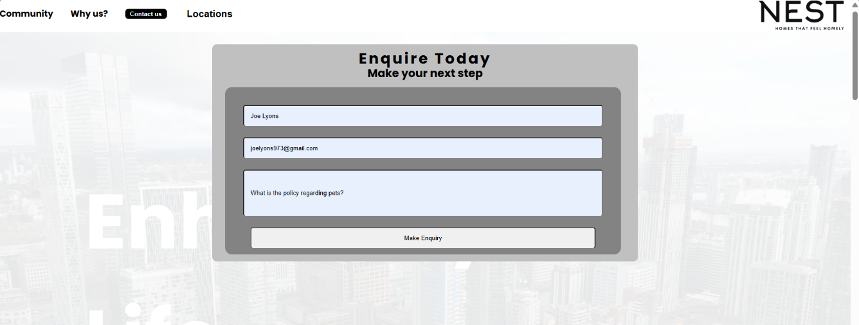**Figure 19.** Enquiry form greeting users after pressing the contact button.

Upon submitting the form a JavaScript function will be called “submitform()”, this function using the “emailjs” API will send an email to the email specified using a pre-defined email template (REFERENCE).

**JavaScript submitform() function**

**function** submitform(){

**const** info = document.getElementById("enquire");

**let** name = (info.elements["name"]).value;

**let** email = (info.elements["email"]).value;

**let** enquiry = (info.elements["enquiry"]).value;

    emailjs.send("service_zko5yuh","template_hq7voyf",{

        to_name: name,

        message: enquiry,

        email: email,

        }, "_fC1jhZcfXnMvi2yl").then(

            (response) **=>** {

                alert("Enquiry logged!");

            },

            (error) **=>** {

                alert("Please retry");

            },

        );

}

**Results and Discussion**

**Testing**

**Accessibility testing**

Using browser development tools, the site has been simulated with various dimensions including differing phone dimensions. The site was able to display the information in a clear readable format regardless of dimensions.

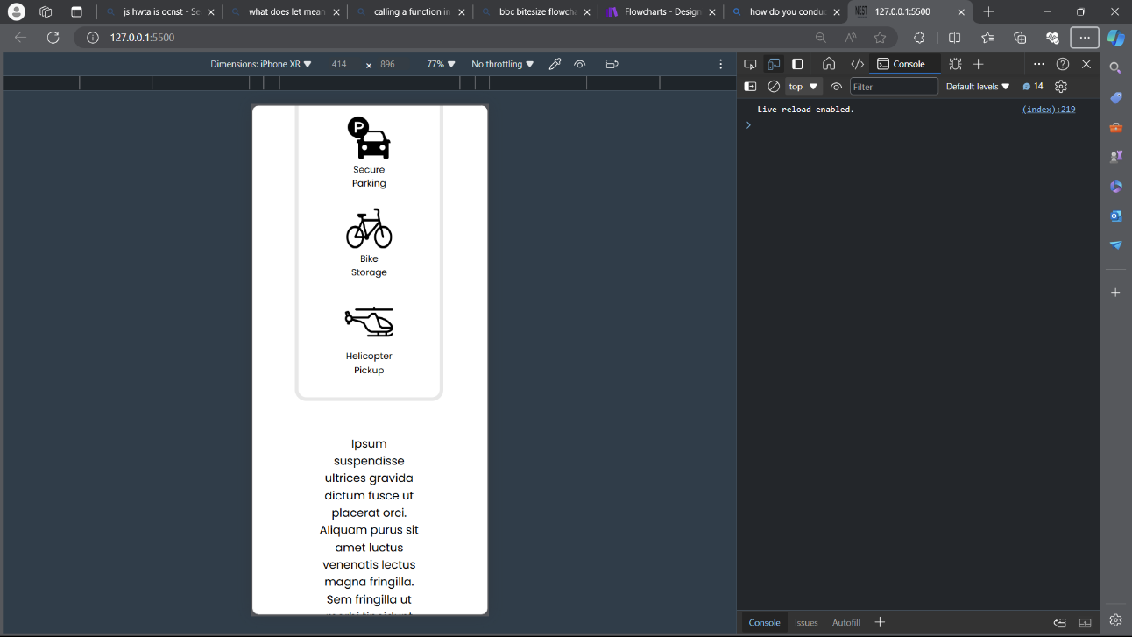**Figure 20.** Accessibility testing using browser tools

**User testing**

|  |  |  |  |
| --- | --- | --- | --- |
| Can differing location pages be accessed? | Yes, all location pages can be easily accessed. | Do all buttons work? | All buttons work as intended. |
| Do all links direct to the intended location? | Yes, all links direct the user to the specific page intended. | Is an email received when an enquiry is logged? | Yes, an email is received as seen in Figure 18. |
| Is data in a clear readable format? | All data can be easily read due to the large-spaced text with key information highlighted. | Can the page size be adjusted without compromising readability | Yes, readability is maintained when adjusting the page size. |

**Conclusion and Further Work**

**Have the aims and objectives been met?**

* *The website is aesthetically pleasing.*

The site has conformed to popular modern styles maintaining a simplistic look, this style has been deemed to be aesthetically pleasing (REFERENCE).

* *Relevant helpful information is displayed.*

Yes, simplified clear information is displayed.

* *The site is accessible.*

Yes, the site has multiple links to differing pages throughout and maintains dynamicity allowing for the support of varying screen sizes.

* *It is easy to find relevant information.*

Yes, key information is highlighted with differing font weight and size, this information is also responsive, changing size when interacted with.

* *The website is responsive.*

Yes, hover selectors and buttons are included across the site.

* *Users can enquire using the site.*

Yes, every page contains an enquiry section along with contact details, when an enquiry is made an email is automatically sent to the user detailing the enquiry process.

All aims and objectives have successfully been met.